**Azure Databricks Assignment 2**

Name: **Harish Er**

1. **Load the Dataset:**

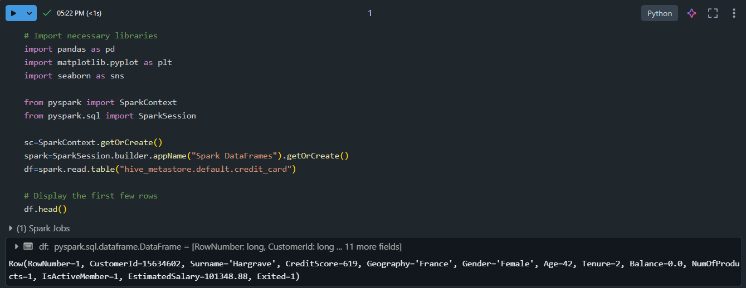

1. **Check for Missing Values:**

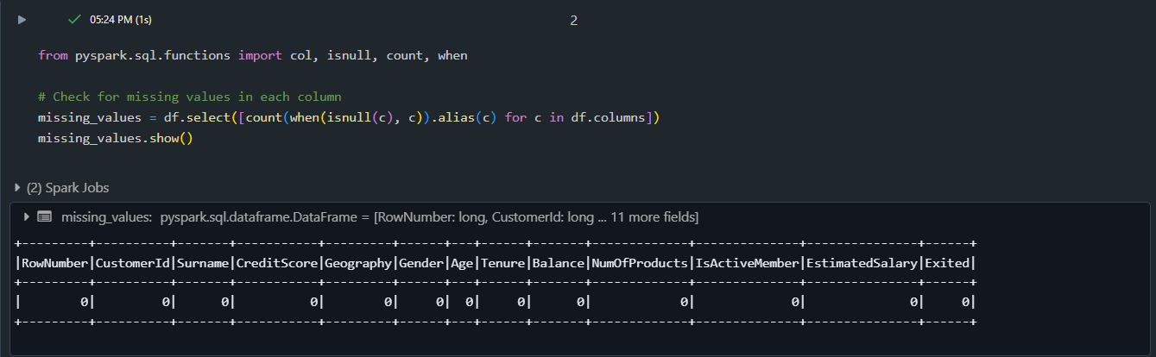

1. **Basic Statistics for Numerical Columns:**

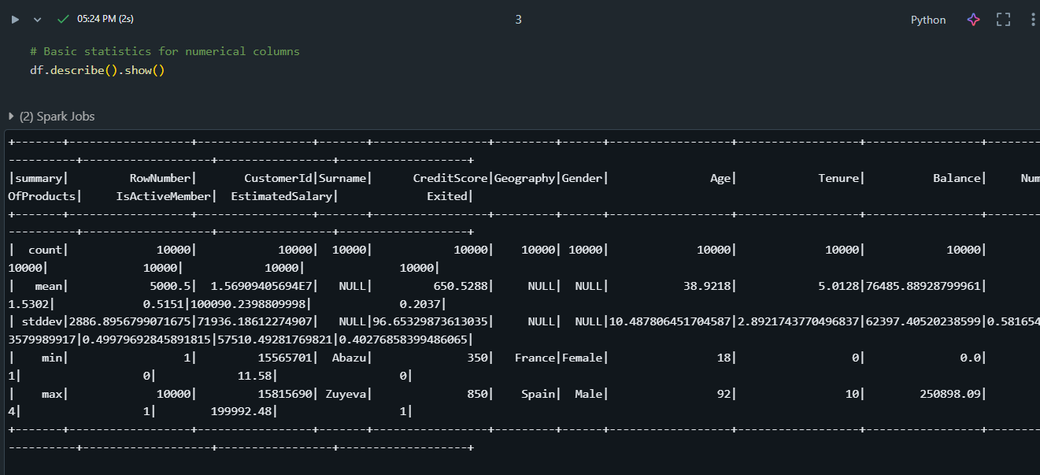

1. **Handle Missing Values:**

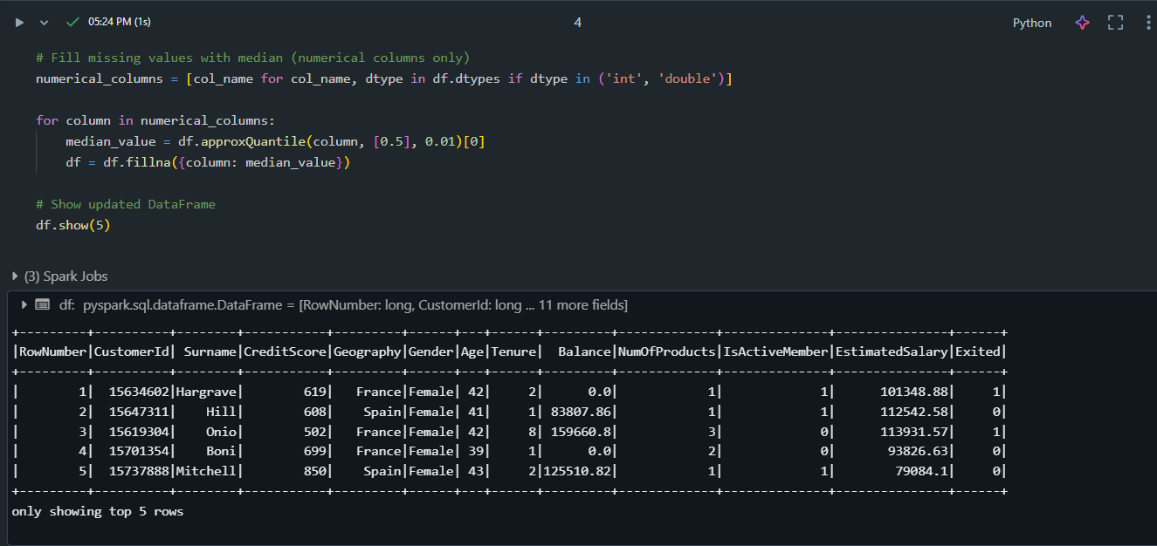

1. **Drop Duplicate Rows:**

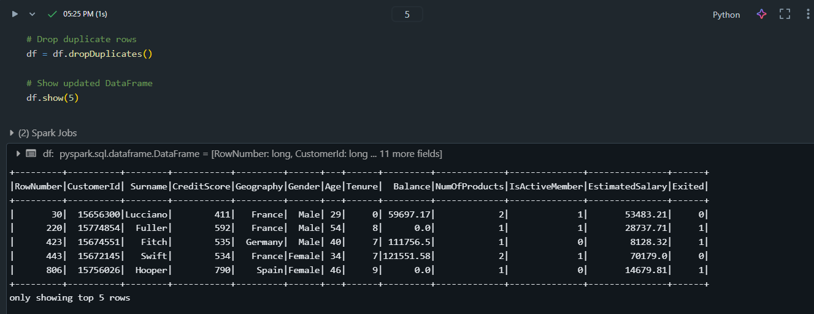

1. **Correlation Heatmap for Numerical Columns:**

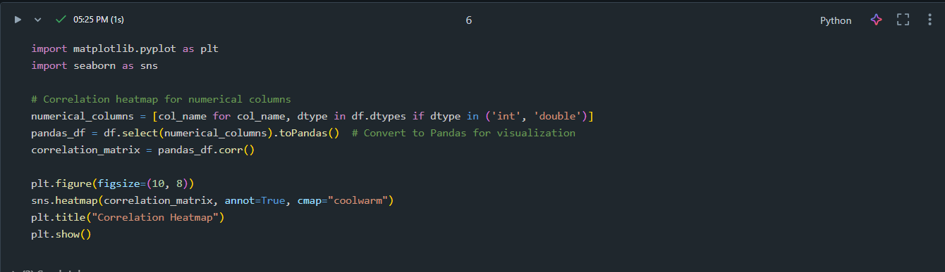

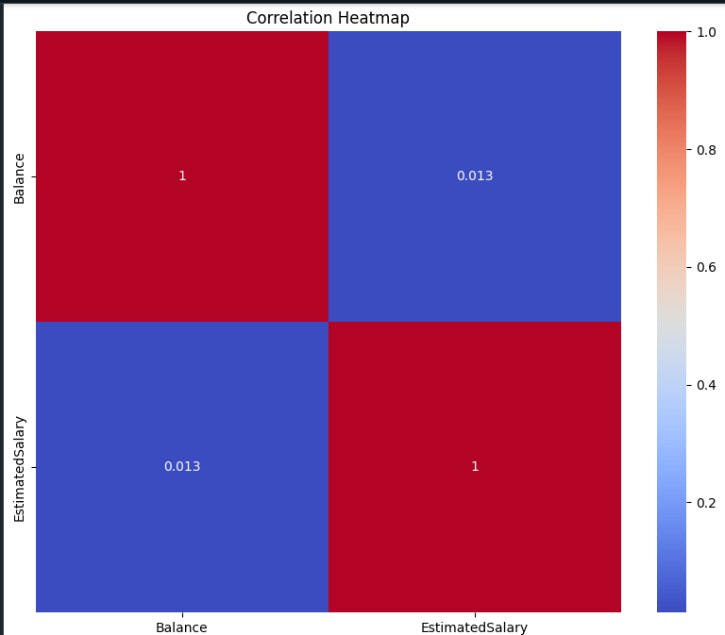

1. **Distribution Plot for a Specific Column:**

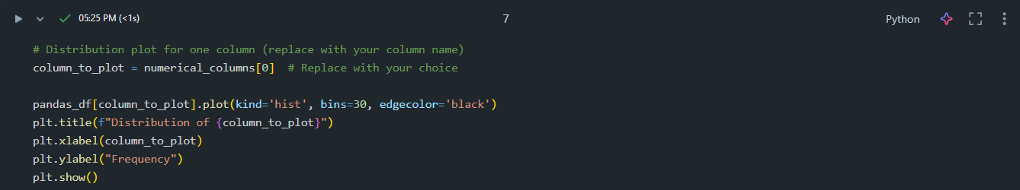

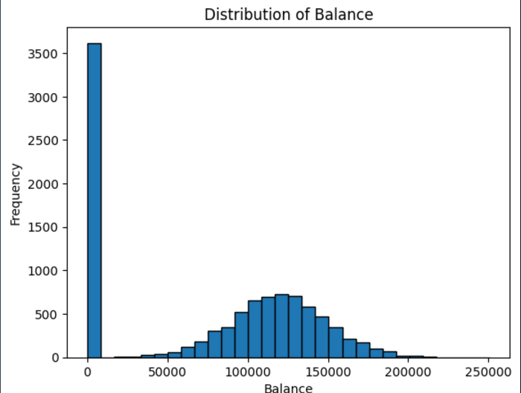

1. **Value Counts for Categorical Columns:**

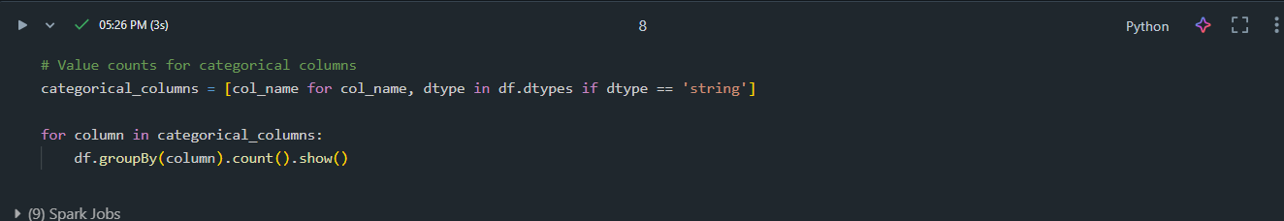

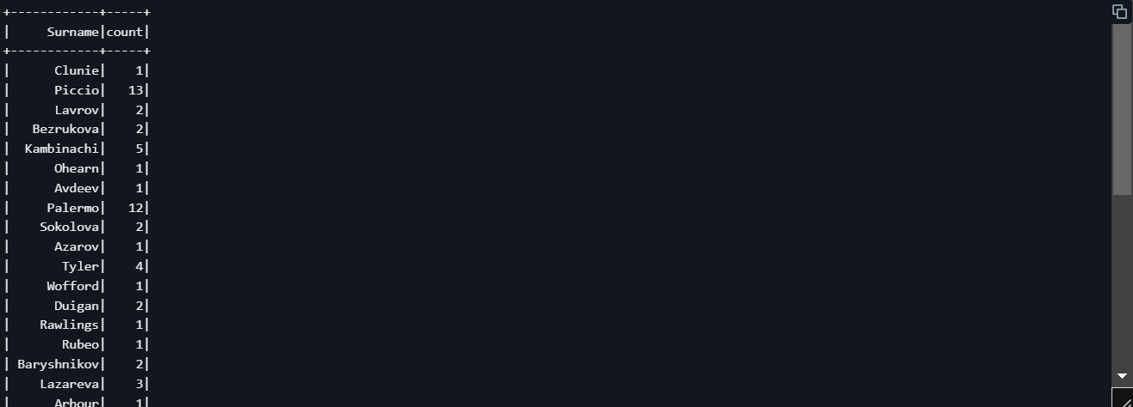

1. **Boxplot for Outlier Detection:**

